Programming Assignment – 2

CS 2133 Computer Science II

*Due: 09/23/2020 at 9:00 AM on CANVAS*

Read through each problem and write a JAVA program to implement the solution.

1. Turn in individual JAVA files on Canvas.
2. ALL JAVA programs titled: LastName_ProblemX.java – where X is the problem number
3. There should be a separate JAVA file for each problem, e.g., If you will have 3 problems, you will submit 3 separate JAVA files.
4. Please add comments in the program detailing your solution for each problem. Why you chose the loop you used – counter-based, early-test, etc. Your comments should contain a very brief (maximum 4 lines) description of each solution.
5. All programs will be tested for completeness on three different test cases.
6. **Unless otherwise specified please do not use pre-defined libraries or functions.**

Problem 1: (5 points)

Write a Java program to perform Matrix addition. You can hardcode/declare your matrix in the program itself.

*Hint: Remember a Matrix can be considered to be a 2 dimensional matrix. Matrix addition should be done between matrices of same size. Matrix addition is simply the sum of the elements in the same position in the two matrices.*

Example:

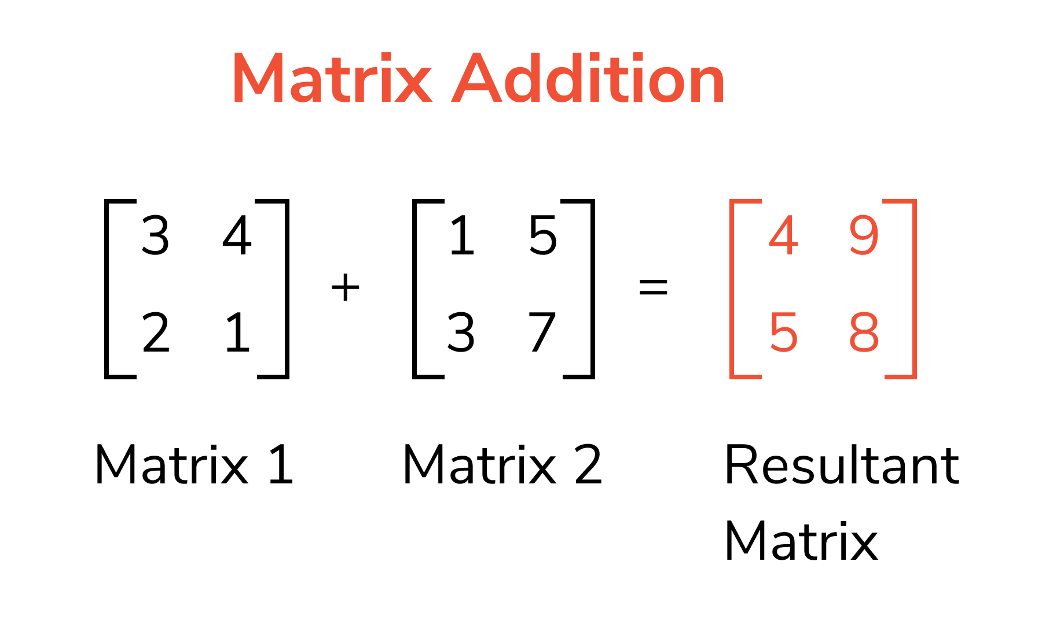

Problem 2: (10 points)

Write a program so that the numbers in the array appear in reversed order without creating a new array. You will need to use a temporary variable to do this.

Problem 3: (10 points)

Write a Java program to find the second largest and smallest element in an array. You should be able to handle both single and multidimensional arrays.

Bonus problem: (5 points)

Given a 2D array A, your task is to convert all the rows to columns and columns to rows.

Example:

